**

**Mathematics Specialist Unit 1**

# Test 5

**Matrices**

|  |
| --- |
| **Name: ______________________ Total Marks:__________** |
|  |
|  |

**Task type: Response**

**Time allowed for this task:** 60 minutes, in-class, under test conditions

Section One: Calculator-free 30 minutes ( 19marks)

Section Two: Calculator-assumed 30minutes ( 30marks)

**Materials required:** Calculator with CAS capability (to be provided by the student)

**Standard items:** Pens (blue/black preferred), pencils (including coloured), sharpener, correction fluid/tape, eraser, ruler, highlighters

**Special items:**  Drawing instruments, templates, notes on one unfolded sheet of   
A4 paper, and up to three calculators approved for use in the WACE examinations

Formula sheet

**Marks available: 60 marks**

**Task weighting: 8.5%**

**Section One : Calculator Free 27 Marks**

**Time Allowed 30 minutes**

**Question 1**

**[7 marks]**

Given that $A=\left[\begin{matrix}2 & -1 \\ -5 & 3\end{matrix}\right]$ , $B=\left[\begin{matrix}1 & 0 \\ 3 & -5\end{matrix}\right]$ and $I$ is the $2×2$ identity matrix.

Find

$A+B$

$3B$

$2A – B +I$

$AB$

$A^{-1}$

**Question 2**

**[5 marks]**

For the matrices

$A=\left[\begin{matrix}0 & 1 \\ 5 & 3 \end{matrix}\begin{matrix}4 \\ 3\end{matrix}\right]$ $B=\left[\begin{matrix}1 & 0 \\ -2 & 4\end{matrix}\right]$ $C=\left[\begin{matrix}5 & -2\end{matrix}\right]$ $D=\left[\begin{matrix}1 & -4 \\ 0 & 1 \\ 6 & -2\end{matrix}\right]$

1. Which pairs of matrices can be added?
2. Write down all the pairs of matrices that can be multiplied.
3. Multiply the two matrices that will give a product that is a square matrix.

**Question 3**

**[4 marks]**

Given vectors $a = 2i+7j$ and $b=-6i+8j$

Find

$\left|b\right|$

$a.b$

1. Find the vector projection of $a$ onto $b$

**Question 4**

**[3 marks]**

Write the equation of the following graph in the form $y=a\sin\left(bx\right)+d$

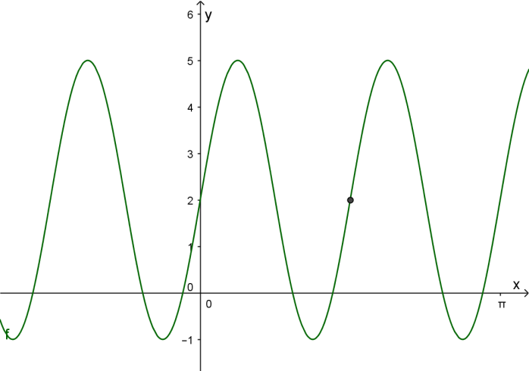

$$(\frac{π}{2},2)$$

**Question 5**

**[8 marks]**

1. Rewrite the following in terms of matrix $X$
$2X+A=B$

$AX+BX=C$

$XA=B+2X$

2. For the non-singular matrices $A$**and $B$** such that $AB=BA$**. Show that $A^{2}=BA^{2}B^{-1}$**

**Section Two : Calculator Assumed 30 Marks**

**Time Allowed 30 minutes Name:_______________________**

**Question 6**

**[5 marks]**

1. Express $\sin{θ}+5\cos{θ}$ in the form $R\sin{(θ+α)}$ for an acute angle in radians.
2. Hence determine the maximum value of $\sin{θ}+5\cos{θ}$ and the smallest positive value of $θ$ at which this occurs.

**Question 7**

**[4 marks]**

A body is acted on by the forces as shown in the diagram.

Find the magnitude and direction of the resultant force.

30°

20 N

15°

30 N

**Question 7**

**[4 marks]**

Consider the system of equations:

$$2y=12+x$$

$$2x+3y=17$$

a) Write this system as a matrix equation. (2)

b) Solve the system using matrix methods. (2)

**Question 8**

**[4 marks]**

Given that $A=\left[\begin{matrix}x+3 & 5 \\ -2 & -x\end{matrix}\right]$

1. Find, in terms of x, the determinant of matrix $A$**.**
2. Find the greatest value of $x$ that makes the matrix $A$ singular.

**Question 9**

**[4 marks]**

1. Find the $2×2$ transformation matrix representing a rotation of 30 $°$ anti-clockwise about the origin
2. Find the $2×2$ transformation matrix representing a rotation of 45 $°$ anti-clockwise about the origin.
3. Hence, find the transformation matrix that represents a 75 $°$ anti-clockwise rotation about the origin.

**Question 7**

**[3 marks]**

Use matrices to find the image of the line $x-3y=1$ after it is reflected in the line $y=-x$.

**Question 10**

**[8 marks]**

On a normal Monday’s trading, BRASH’S Melville store sell, on average, 8 televisions, 12 music systems and 6 digital video recorders. In comparison, the Cannington store sells, on average, 4 televisions, 9 music systems and 5 digital recorders.

a) Represent this information as the matrix **S**. (2)

b) The profits ($) on each item can be represented by matrix **P**, where **P** =  (2)

Calculate SP.

What do the entries tell you?

For their MAD MONDAY SALE, profits were reduced by 40% and the following quantities sold.

Melville : 4 televisions, 6 music systems and 10 digital video recorders

Cannington : 5 televisions, 5 music systems and 6 digital video recorders

c) Use matrix operations to determine the overall increase or decrease in profit for the two stores on MAD MONDAY over a normal Monday. (4)